NBA Dashboard Analysis Report
Prepared by: Manushree Madhwani
Tool Used: Microsoft Power BI
Date: May 2026

Table of Contents

1. Executive Summary 3
2. Objectives 3
3. Methodology 3
4. Dashboard Overview 4
4.1 Overall Dashboard 4
4.2 Player Performance Analysis 4
4.3 Match & Advance Insights 4
5. Key Findings 5
6. Recommendations 5
7. Conclusion 5
8. Appendix 6

1. Executive Summary
This report provides a comprehensive analysis of NBA dashboards developed in Power BI. The dashboards consolidate player and team statistics into interactive visualizations, enabling stakeholders to explore performance metrics, efficiency drivers, and seasonal trends.
Key insights include:
- Competitive balance across teams with nearly equal win/loss ratios.
- Star performers such as Nikola Jokić and Luka Dončić consistently leading in scoring and efficiency.
- Turnovers and shooting percentages as critical drivers of match outcomes.
- Seasonal scoring peaks in January and March, with reduced offensive impact in May.

2. Objectives
- To present NBA statistics in a visual, interactive format.
- To enable comparative analysis of players and teams.
- To identify performance drivers such as shooting efficiency, turnovers, and rebounds.
- To provide seasonal trend analysis for management and coaching decisions.

3. Methodology
- Data Source: Aggregated NBA statistics (points, assists, rebounds, shooting percentages, turnovers, win/loss records).
- Tool: Microsoft Power BI for visualization and interactivity.
- Approach:
  - Developed summary metrics for quick insights.
  - Designed comparative charts (bar, scatter, donut, line) for player and team analysis.
  - Integrated filters for dynamic exploration by team and player.

4. Dashboard Overview

4.1 Overall Dashboard
- Summary Metrics: 202 games, 302K points, 70K assists, 115K rebounds.
- Top Scorers: Shai Gilgeous-Alexander, Donovan Mitchell, Jalen Brunson, Luka Dončić.
- Team Comparison: CLE and SAS lead in combined points, assists, and rebounds.
- Win/Loss Ratio: Balanced at ~50%.
- Game Score Leaders: Nikola Jokić (28.2), Luka Dončić (26.4).

4.2 Player Performance Analysis
- Shooting Efficiency: Bubble chart comparing FG% vs points.
- Shooting Breakdown: Distribution of FT, FG, and 3P.
- Player Stats Table: Detailed metrics (FT%, FG%, 3P%, blocks, assists, rebounds, +/-).
- Top Assist Providers: Nikola Jokić, James Harden, Jalen Brunson.

4.3 Match & Advance Insights
- Minutes vs Performance: Correlation between playing time and match outcomes.
- Turnovers vs Result: Wins (1387 turnovers) vs Losses (945 turnovers).
- Impact Analysis: +/- scores highlight player influence (e.g., Jokić, Wembanyama).
- Rebounds Distribution: Rudy Gobert and Jalen Duren dominate offensive rebounds.
- Seasonal Trends: March and January peak in scoring; May shows reduced offensive impact.

5. Key Findings
- Competitive Balance: Win/loss ratio indicates parity across teams.
- Efficiency Drivers: Shooting percentages and turnovers directly affect match outcomes.
- Player Impact: Jokić and Dončić consistently lead in scoring and efficiency.
- Team Strengths: CLE and SAS demonstrate balanced contributions across metrics.
- Seasonal Variations: Performance fluctuates monthly, with notable peaks in March.

6. Recommendations
- For Coaches: Focus on reducing turnovers and improving shooting efficiency.
- For Analysts: Use seasonal trend data to forecast performance dips and peaks.
- For Management: Leverage player impact scores in recruitment and trade decisions.
- For Fans/Media: Provide interactive dashboards to enhance engagement and storytelling.

7. Conclusion
The NBA dashboards developed in Power BI successfully transform complex statistical data into actionable insights. They provide a holistic view of performance, enabling stakeholders to make informed decisions on player development, team strategy, and season planning.

8. Appendix
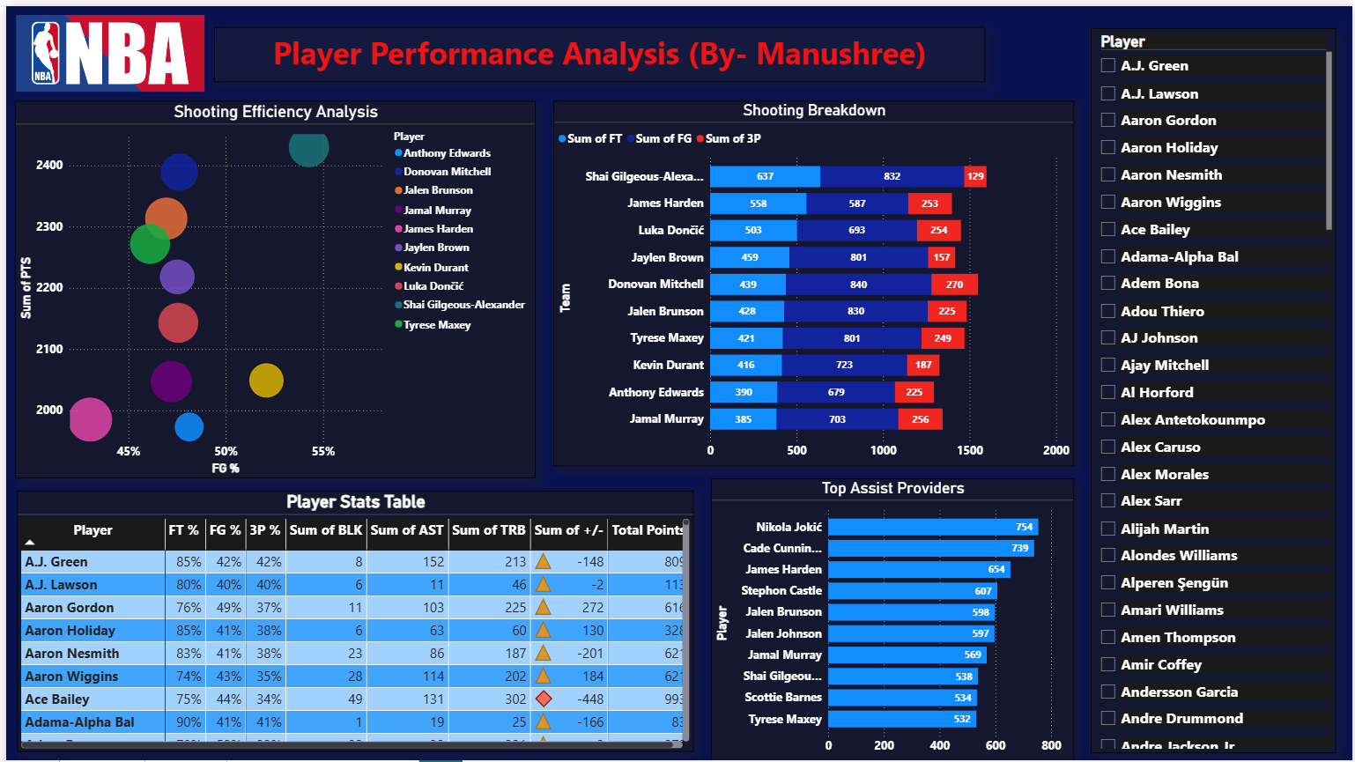
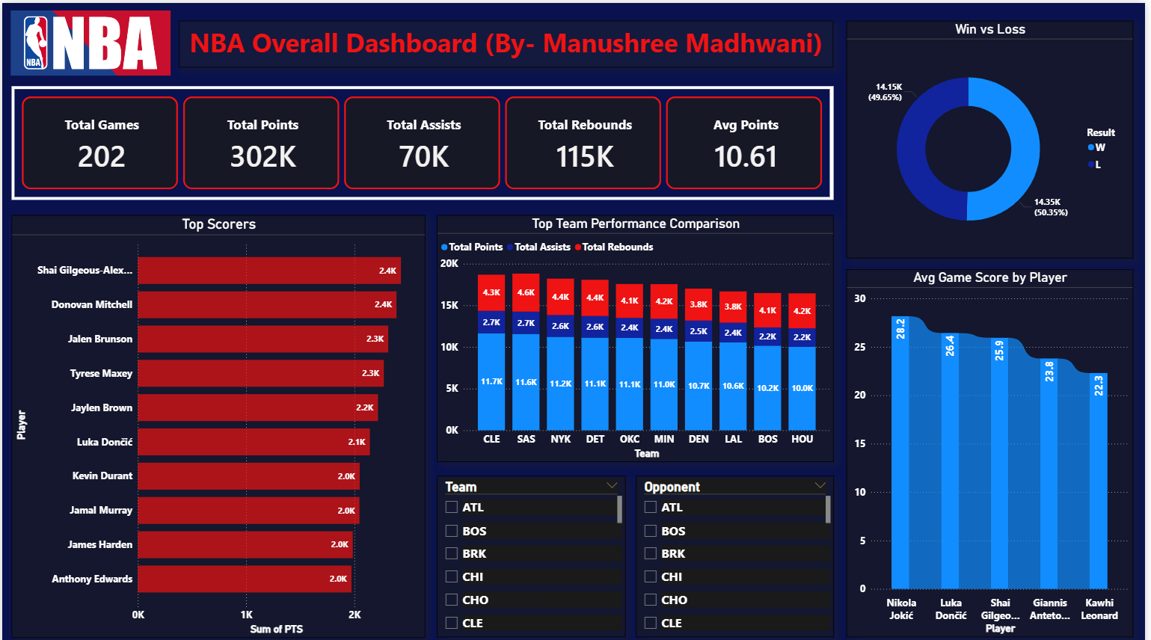
- Dashboard Screenshots:
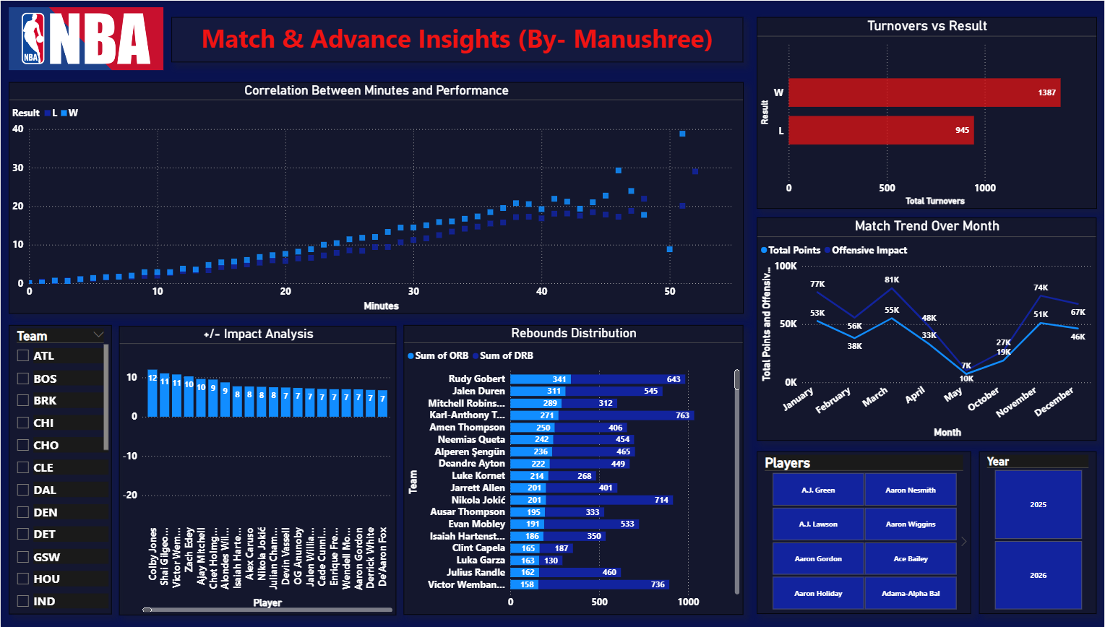
- Glossary of Metrics:
- FG% (Field Goal Percentage): The percentage of field goals made out of total attempts.
$$FG\%=\frac{\text{Field Goals Made}}{\text{Field Goals Attempted}}×100$$
It measures overall shooting efficiency from the floor (excluding free throws).
- FT% (Free Throw Percentage): The percentage of free throws made out of total attempts.
$$FT\%=\frac{\text{Free Throws Made}}{\text{Free Throws Attempted}}×100$$
It reflects a player’s accuracy from the free-throw line.
- 3P% (Three-Point Percentage): The percentage of three-point shots made out of total attempts.
$$3P\%=\frac{\text{Three-Point Shots Made}}{\text{Three-Point Shots Attempted}}×100$$
It indicates a player’s efficiency from beyond the three-point arc.
- +/- Impact (Plus-Minus Rating): A measure of the point differential when a player is on the court.
  - Positive (+): Team outscored opponents while the player was playing.
  - Negative (–): Team was outscored during the player’s minutes. It captures overall impact on team success, not just individual stats.
- ORB (Offensive Rebounds): The number of rebounds a player secures on the offensive end, giving their team another scoring opportunity.
- DRB (Defensive Rebounds): The number of rebounds a player collects on the defensive end, preventing the opponent from a second chance to score.

- Data Notes: All statistics are aggregated from NBA 2025-2026 season datasets.

